EVENT EMERGENCY EVACUATION PLAN
EVENT NAME
EVENT LOCATION ADDRESS
EVENT DATE

Event Emergency Roles and Contacts

Role | Name | Phone
Chief Warden
Deputy Chief Warden
Communications Officer
Security – Guardian

Area Wardens

Area Wardens: # | Area | Warden | Contact
1 | Food and Stall | Operation Staff
2 | Stage, face & Henna | Operation Staff
3 | Carnival | Operation Staff

Assembly Area
Assembly Area: # | Area | Assembly Point
Area 1 |  | Basketball carpark
Area 2 |  | Coronation Park carpark
Area 3 |  | Coronation soccer field

Event Evacuation Map
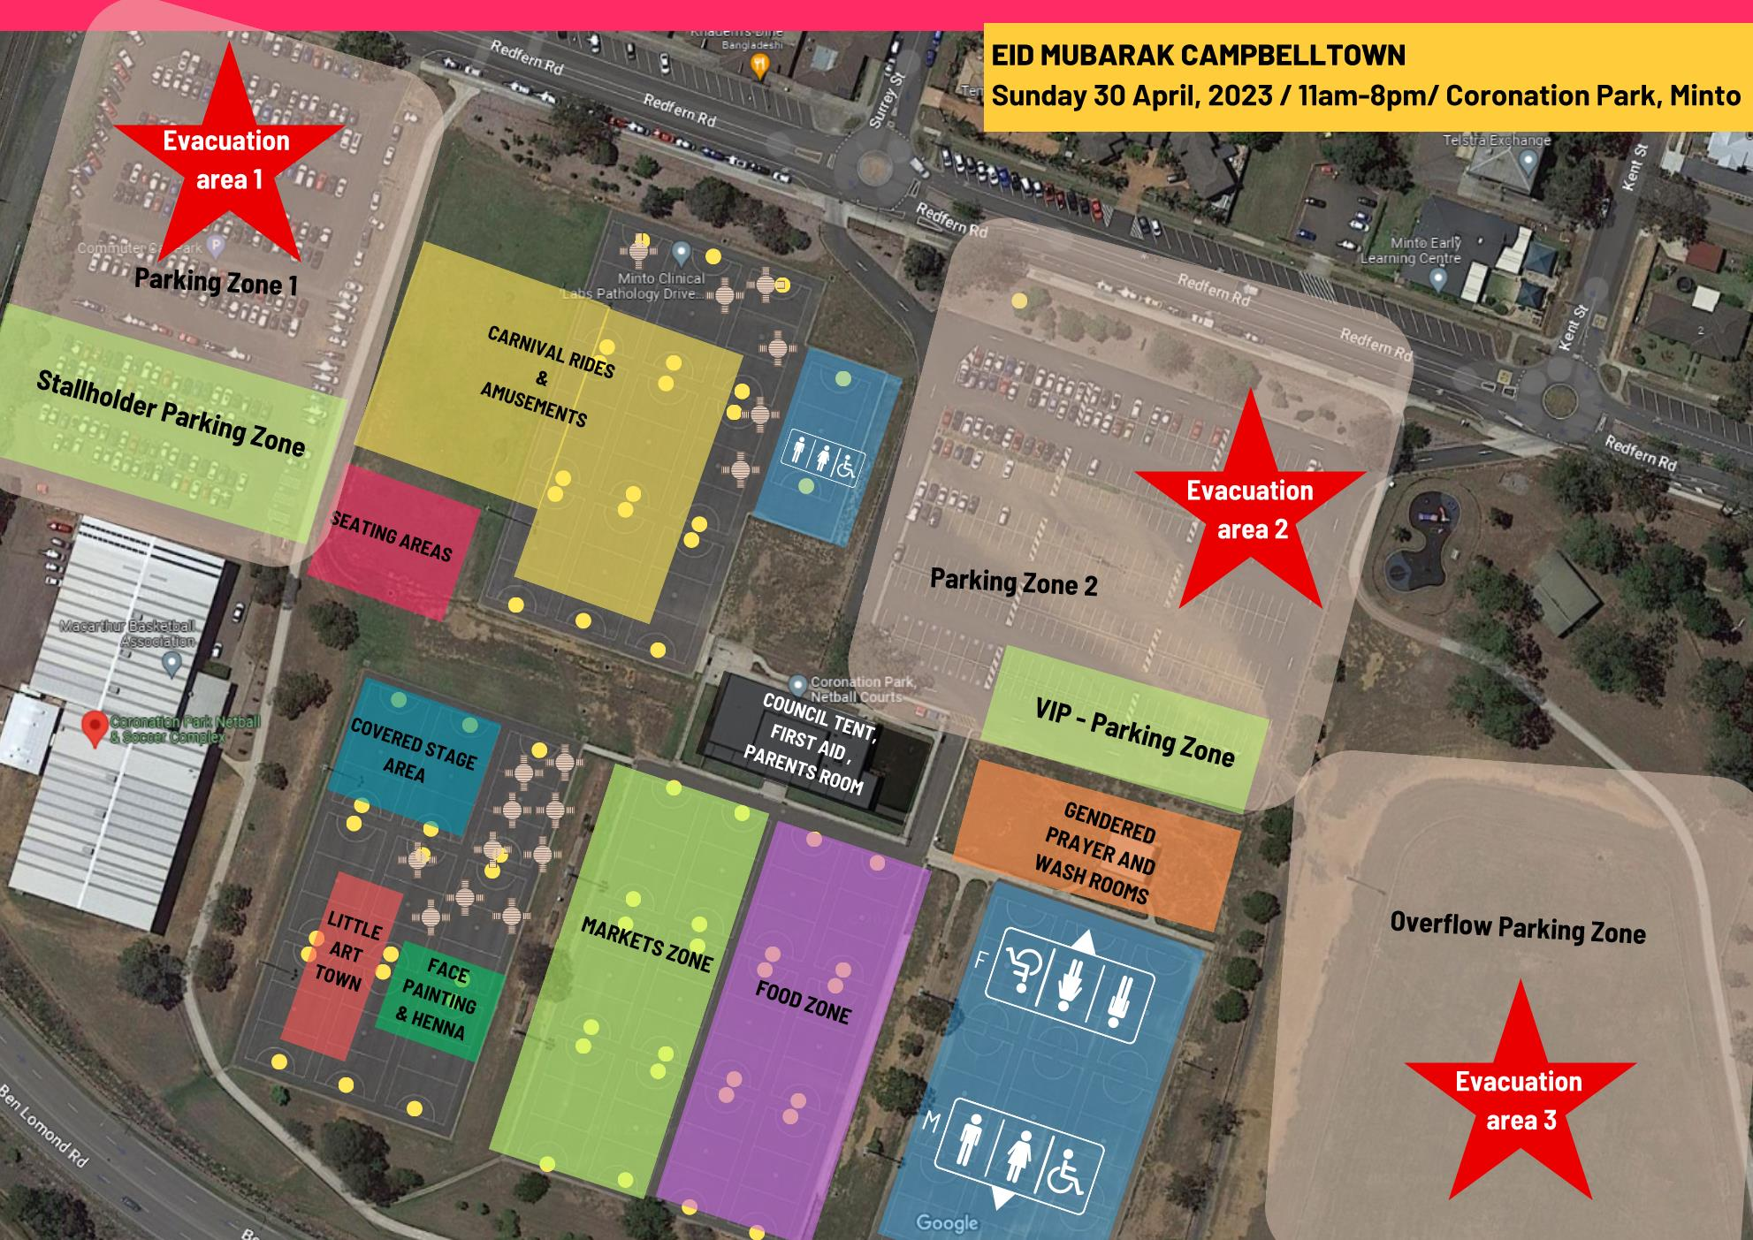

The Roles and Responsibilities of the Chief Warden:

CHIEF WARDEN
NORMAL | EMERGENCY
Develop Emergency Plan | Take Control of Emergency Situation
Administer Warden System | Make the Decision to Evacuate
Supervise Staff and Visitors on Site | Notify Emergency Services and Venue
Implement Reporting and Debriefing Systems | Remove all Staff and Patrons from Area
Ensure Council is Aware of on Site Incidents | Hand Over / Assist Emergency Services
If Absent - Ensure Deputy Warden is on Site | Log and Report all Emergency Incidents

The Roles and Responsibilities of the Deputy Chief Warden:

DEPUTY CHIEF WARDEN
NORMAL | EMERGENCY
Assist Chief Warden | Assist Chief Warden
Assume Chief Warden Role when Absent | Assume Chief Warden Role when Absent

The Roles and Responsibilities of the Area Wardens:

AREA WARDENS
NORMAL | EMERGENCY
Understand Venue Layout | Report Immediately to Chief Warden
Ensure Exits are ALWAYS free from Obstruction | If Evacuation is Signalled Open Exit Gates (if applicable)
Know Locations of 1st Aid | Ensure ALL Designated Exits are Clear
Know Locations of Emergency Equipment | Remain Calm — Direct Patrons NOT to Run
Assist with Inductions of Workers in their Area | Evacuate in Opposite Direction to Concern Area
Supervise Workers within their Area | Give Assistance to Accessible Patrons
Report Risks / Hazards to Chief Warden | Report to Chief Warden when Area is clear

The Roles and Responsibilities of the Communications Officer:

COMMUNICATIONS OFFICER
NORMAL | EMERGENCY
Liaise with Chief Warden if announcement is required | Make stage announcement with instructions to patons
Ensure Contact List is available | Notify Chief Warden of Emergency
Attend to Emergency Calls | Maintain Emergency Incident Log
Notify Appropriate Emergency Services | Maintain Emergency Incident Log

Reporting Emergency Situations:

It is important that emergency situations are reported immediately and clearly without panic or interference. Report the situation to the Chief Warden or a supervisor with a radio immediately.

The following information is required:

- Your Name, Position and Location
- The Nature of the Emergency
- The Assistance Required
- Any Other Relevant Information

It is important to remember after reporting the situation, to only speak when asked to do so to ensure the radio channel is free for essential communication.

Evacuation Announcement:

In the event of an evacuation the Chief Warden will make the following announcement:
Ladies and gentlemen, due to circumstances beyond our control today’s event can no longer continue. For public safety reasons we ask you to vacate (advise relevant area) and surrounding areas in an orderly manner. Please remain calm do not run. Please follow the instructions of our security and event staff. Thank you.

The Decision to Evacuate:

Should the magnitude of an incident or situation warrant an evacuation, the assessment will be made by the Chief Warden in consultation with the following key personnel and agencies:

- Event management staff
- Security
- NSW Emergency Services and/or Police

This assessment will include a decision on the size and the appropriate point of evacuation.

Immediate Evacuation:

In some instances it may be necessary to evacuate the site without consulting key personnel and agencies. In this case due consideration MUST be given to:

- Is it safer not to evacuate?
- How many people will need to be evacuated?
- Are the marshalling points and evacuation routes appropriate for this emergency?
- Which way is the wind blowing (if fire is present)?
- Will moving people to these locations cause them to pass through the incident?
- Is the path of travel obstacle free?
- Does this evacuation fit in with the local area disaster plan?
- Which direction will emergency services arrive from?
- Have the venue been notified of the incident?

The Size of the Required Evacuation:

The type of evacuation required will depend on the nature of the emergency and will generally be determined by the Chief Warden and Emergency Services. Evacuations fall into two categories:

• FULL- ALL patrons and employees moving out of the event area.
• PARTIAL - Designated patrons and employees moving out of the incident area.

Crowd Management for Evacuation:

Across the entire event site, crowd and pedestrian management is carried out by security staff under the direction of the Chief Warden. Static and response teams are responsible for ensuring that all walkways and emergency access / egress points remain clear at all times.
It is conceivable that from time to time some walkways may become congested and under these circumstances alternate emergency and evacuation routes will be identified.

The Evacuation Procedure for the Event:

The following evacuation procedure applies for the event:
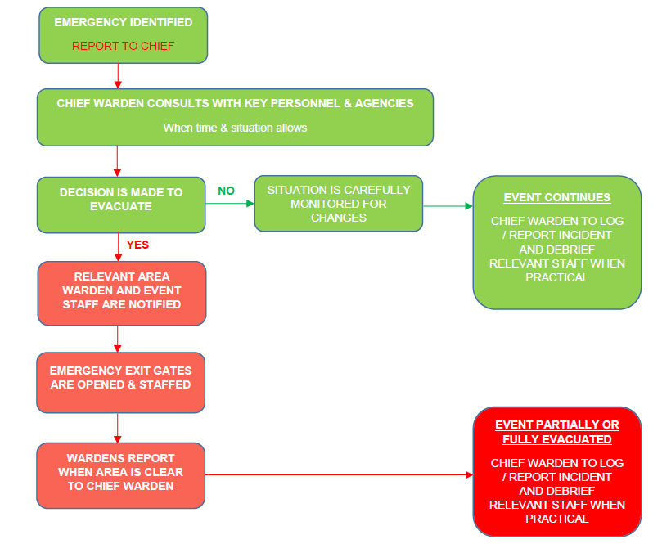

Emergency Services Hold Ultimate Control:

The above are guidelines only and are subject to change to suit the location of the emergency, type of emergency, crowd density and wind conditions. Emergency services out rank all event and site management. Should they give any personnel a direct order; they should carry out the order. Confirmation from event control is not required.

Emergency Vehicle Access:

When notified, emergency services should be advised of the approximate location of the incident and the most suitable entrance point into the event site. On arrival, the closest area warden is to meet the emergency services vehicle and guide them to the exact incident position. There will be a minimum 3.5m access corridor maintained throughout the site.

Considering Accessible Patrons in Evacuation:

In the event of an evacuation, area wardens will assist or arrange assistance for accessible patrons within the event site. An accessible person is considered anyone who will require physical assistance during an evacuation.

Accessible patrons include:

- Permanent Disablement
- Temporary Disablement - Injury, Advanced Pregnancy etc.
- Sensory Disablement - Deaf, Blind etc

